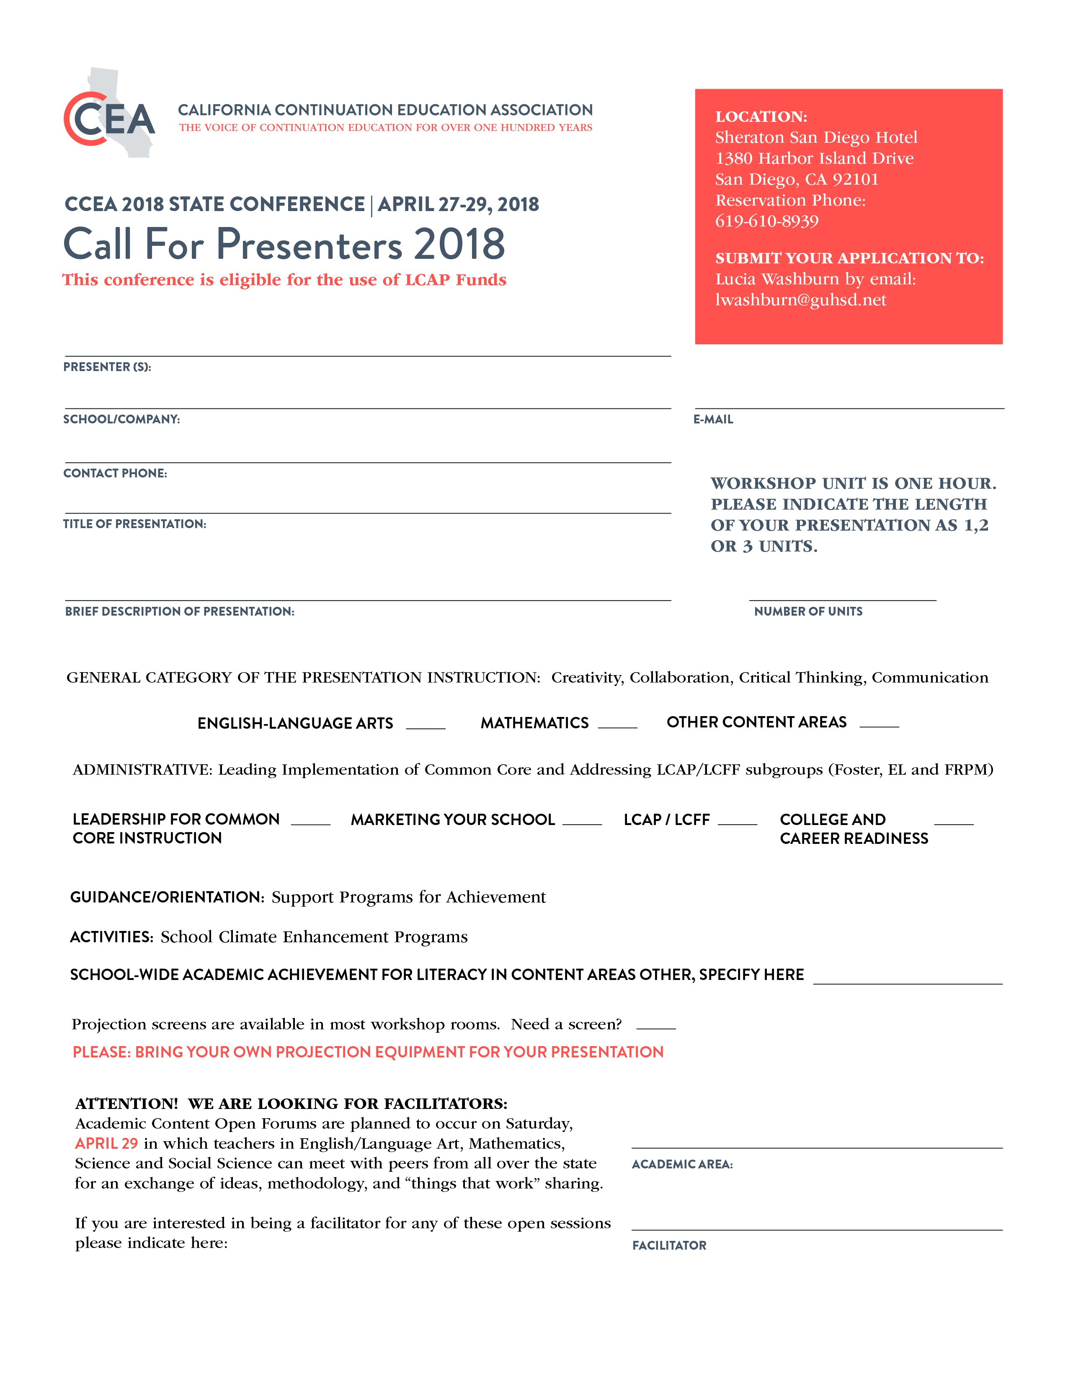

WRITE HERE

WRITE HERE

SPECIFY HERE

Y/N

ENTER HERE

WRITE HERE

TITLE NAME

SCHOOL NAME

CONTACT NAME

PRESENTER(S)

E-MAIL HERE